Water Testing and Health and Safety Information

1 Water Test: Introduction
2 Different Types of Water Pollution
3 Safety Guidance
4 When to Test
5 How to Test
6 What to do if polluted water is found
7 Pumping Guide
8 Pumping Equipment & Performance

Water Test: Introduction
The telecommunication underground network of ducts and jointing chambers acts as a drainage channel in many cases for rainwater and for groundwater, which may enter via duct joints. Whilst this water is in the majority of instances harmless, circumstances do arise in which water becomes contaminated.
Pumping out of jointing chambers is a frequent operational requirement prior to commencing external underground activities. Water is typically pumped into roadside storm drains or other roadside drainage facility, and can and does make its way into natural waterways. It is a requirement that any such water is tested to ensure that it is visibly free of pollution.
The Environment Agency (EA) is responsible for the protection of "controlled waters", which includes all watercourses and water contained in underground strata. It is an offence under the Water Act 2003 to cause pollution to such waters.

Different Types of Water Pollution
The water test required is a simple operation designed to identify pollutants in the following three categories:
- Petrol and oil contamination, where a film of contaminating fluid will appear on the surface of the water possibly together with a distinctive smell.
- Dirty water contamination, potentially from sewage or other foul water source, which will discolour the water, may result in solid particles in suspension and may be accompanied by an unpleasant or distinctive smell.
- Silt, or very fine solids, drawn in from the surrounding strata by groundwaters entering the structure, which can remain in suspension in the water in the form of a cloudy discolouration, or which may settle to the bottom of the water in the structure to form a layer of sludge but is easily disturbed. The prevention of silt entering natural waterways is as important as prevention of other contaminants and requires care in pumping operations even though silt has not been identified by water test, see pumping guide section 7.

Typical examples of polluted water samples are illustrated below. These illustrations are for guidance only - use your judgement and call for assistance if required.

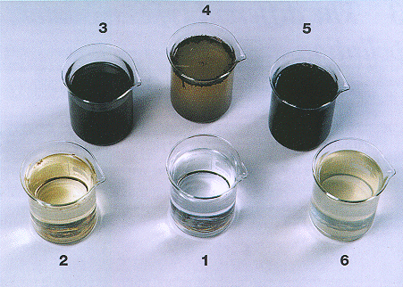

Typical examples of polluted water
- Pure Water
- Sewage
- Silted water
- Silted water
- Oil
- Discoloured Water
Both silted and discoloured water may be of many different colours depending upon the local rock and soil.

Safety Guidance
Appropriate PPE should be worn when conducting any water sampling or pumping including the use of PVC gloves.

When to Test
- The test must always be carried out as part of the initial access procedure for underground jointing chambers, to be conducted during the standard entry precautions for gas.
- A water test is required for every chamber containing water that needs to be removed wholly or in part for operational or safety reasons, see (section 7) pumping guide below.
Water present in a chamber that does not need to be removed for operational or safety reasons need not be tested.

How to Test
- Using a Mills Water Sampling Kit (S83-7602) or a Clean Water Test Cup (S83-1937 -ref 075886) attached to a length of draw rope, carefully take a sample from the surface of the water and withdraw the cup from the chamber.
- Visually examine the water in good light for the presence of:
- unnatural discolouration
- unusual distinctive or unpleasant smell
- cloudy suspension or visible suspended solids
- If any of the above characteristics are observed, the water is deemed to be polluted. Follow the section ''What to do if polluted water is found''.
- If the water is observed to be unpolluted, pumping out may proceed in accordance with pumping guide'' (see section 7).
Return the sample to the water in the chamber. Clean the Water Test Cup or Jar with synthetic rag or a suitable alternative.

What to do if polluted water is found
- Do not perform any work in the chamber or work space
- Replace the chamber cover and contact your supervisor for further information

Pumping Guide
- Dewatering or pumping should be undertaken carefully to minimise the disturbance of silt.
- Do not pump water onto a footway, or into the main running surface of a carriageway.
- Take care to position discharge hoses to avoid hazardous trips for pedestrians and other road users.
- Take care to avoid any water freezing over to form icy patches in frosty weather.
- Run the discharge hose directly into the nearest drain or ditch. Wherever possible, pumped discharges should be directed across grass covered ground to reduce any suspended solids load. Regular monitoring of the pump outflow must take place to ensure that the water being discharged remains clear and that silt is not being discharged. .
- Take care to avoid any water running into premises.

8 Pumping Equipment
Mills offer arrange of manual, petrol and electrical pumps as follows
- S83-0710 Pump Utility Bailer - https://www.millsltd.com/default/pump-utility-bailer.html

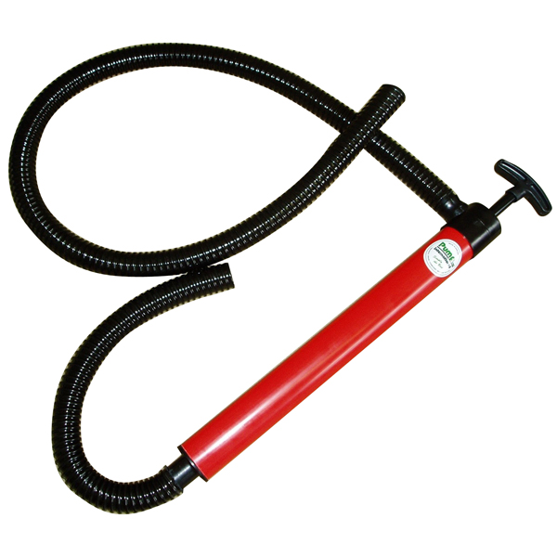

For emptying spaces such as inspection chambers. The short inlet hose and longer discharge hose make this a useful and economical transfer pump. Also known as a bilge pump

- S83-1612 Mills Submersible 3A - https://www.millsltd.com/default/mills-pump-submersible-3a-110v-with-15m-lay-flat-hose.html
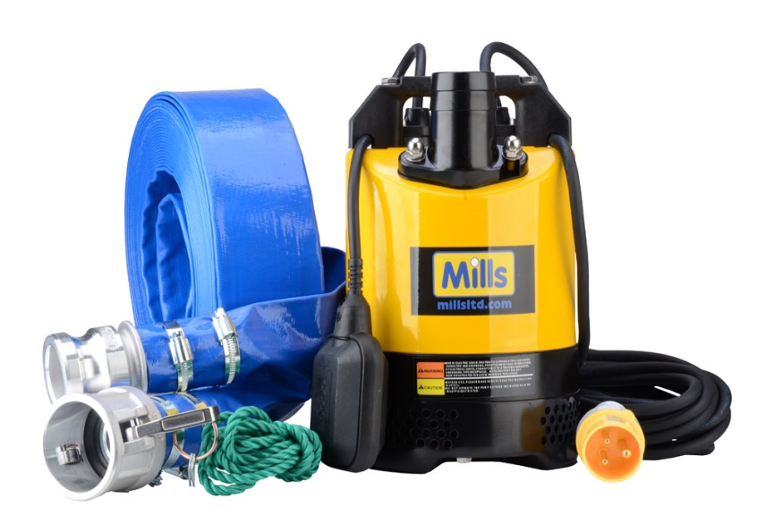

A submersible pump designed for pumping out clean water from telecommunication boxes, pits and chambers.
This 2” (50mm) 110 volt 530w pump weighs just 13kg and can raise water from 11 metres. Supplied with 10m cable and 110v 16 amp plug
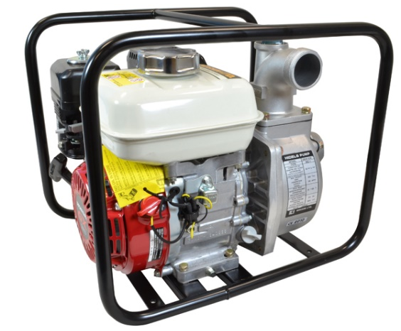
- S83-3249 Pump Portable 2”- https://www.millsltd.com/default/pump-portable-2-inch.html

Ideal for clean and black water applications. 2" inlet and outlets. 620 litres per minute maximum and 30 metres head maximum.
Powered by a strong and durable Honda engine, the lightweight aluminium die-cast pump delivers a high volume of water.
The highly effective mechanical seal with special carbon ceramics provide extreme durability.
The unit is protected by a sturdy steel rollover pipe frame.

